Bug_01:
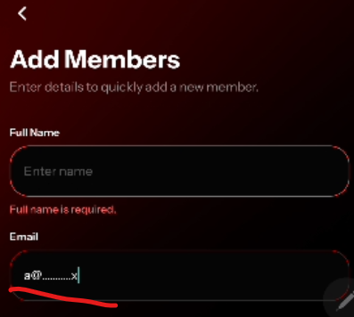
It accepts invalid/ wrong email
Bug_02:
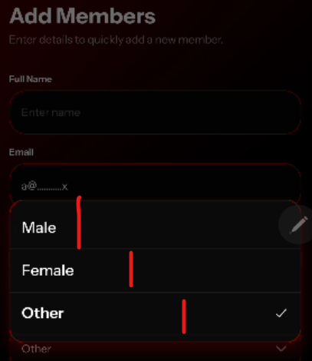
Fields size Consistency issue

Bug_03:
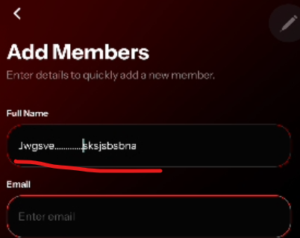
No error message on ……..

Bug_04:
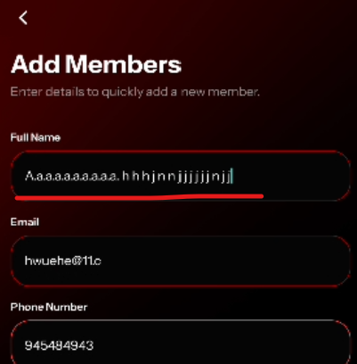
Full Name field allow extra spaces

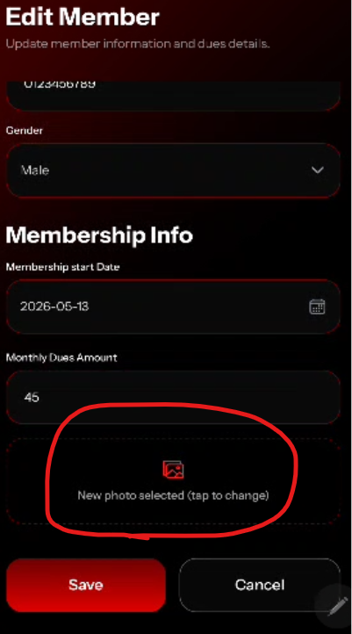

This should not be visible when user can edit image from top

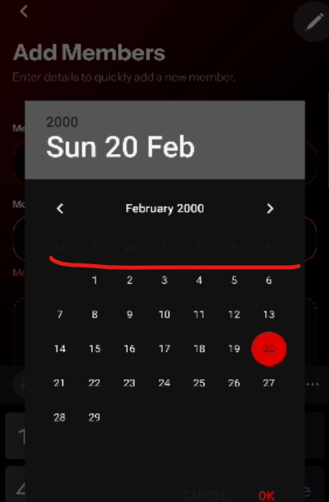
On calendar, days are not visible clearly

